
MPG Calculator™

User Guide

© November 2008 CS451, Inc.

Table of Contents

Introduction 1
Getting Started 2
System Requirements 2
Quick Start 2
Launching the Application 3
Using the Main Menu 4
Adding a Tank of Fuel 5
Entering Vehicle Information 5
Scrolling through Any List in the Application 6
Choosing an Existing Vehicle 7
Entering Fuel Data 8
Saving Fuel Data 10
Displaying Fuel-Saving Tips 12
Displaying Historical Performance 13
Attempting to Summarize or Compare without Stored Data 13
Summarizing Performance for One Vehicle over Time 14
Comparing Performance for One Vehicle over Time 16
Comparing Performance for Two Vehicles 19
Attempting to Compare Two Vehicles When Only One Exists 20
Displaying Performance Comparison 23
Editing/Deleting Data 24
Deleting a Vehicle 25
Editing or Deleting a Tank of Fuel 26
Exporting Historical Performance Data 28
Glossary 30
MPG 30
PDA 30
RAM 30
Smartphone 30
VIN 30

Introduction

Fuel costs are undoubtedly a significant part of your monthly budget. Unfortunately, you cannot control the price of fuel. However, you can control the amount of fuel you use. The only way to make objective choices about your fuel use is to analyze the actual data.

The MPG Calculator™ software doesn’t just calculate your fuel mileage. You could do that with a simple calculator or spreadsheet. With the MPG Calculator™ you can also:
- Store historical performance for one or more vehicles
- Summarize and analyze previous performance for a vehicle
- Compare and analyze current performance with previous performance, which can help you determine when it’s time to get perform vehicle maintenance
- Compare and analyze multiple vehicles’ performance, permitting you to make informed decisions about which vehicle to drive to save the most fuel
- Track fuel costs for business trips, so that you may seek reimbursement from your company or you may deduct those expenses from your taxes*
- Be informed about specific tips which have been proven by experts to help improve vehicle performance

The MPG Calculator™ maintains historical data which can help you analyze your current and past vehicle performance. With this data, you can determine which vehicle is the most fuel efficient. You can then make informed decisions about how much fuel a specific vehicle is using, whether your performance has improved or degraded over time, and even which vehicle is the best for a specific trip.

The MPG Calculator™ does this all with an easy-to-use interface on your Windows Mobile™ smartphone. So, you can take the data with you anywhere you drive, and beyond.

Getting Started

System Requirements

Windows Mobile™ Smartphone
Personal computer
Microsoft ActiveSync™ 4.5

Quick Start

- Insert the MPG Calculator™ Installation CD into your PC’s CD/DVD drive.
- Software installation process should begin automatically. If not, double-click the Autorun.exe file from the CD on the PC’s CD/DVD drive.
- Choose path and folder name for installing the MPG Calculator™ software.
- Finalize installation to the PC.
- Connect Windows Mobile™ smartphone to the PC.
- On the smartphone, begin the sync process. This will launch the Microsoft ActiveSync™ application.
- Once the sync process completes, the MPG Calculator™ software will be ready for use.

Launching the Application

To launch the application from the phone’s Home, choose MPG Calculator™.

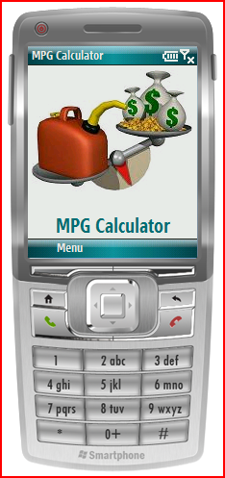

Then choose the Menu option to display the MPG Calculator™ main menu.

Using the Main Menu

Choose one of the following options from the main menu:

Add Tank
Add a tank of fuel to the existing data.

Historical Data
Summarize and/or compare historical data for one or two cars.

Edit/Delete
Edit or delete a car and tank of fuel.

Export
Export historical data to a comma-delimited .csv file, which can then be used to import into a spreadsheet or database.

Exit
Exit the MPG Calculator™ application and return to the phone’s Home.

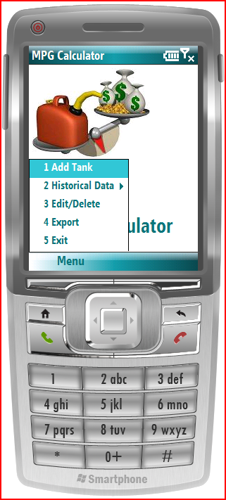

Adding a Tank of Fuel

To add a tank of fuel, choose 1 Add Tank from the MPG Calculator™ main menu.

Entering Vehicle Information

If no historical data exists, the MPG Calculator™ requires entry of a new vehicle. To enter a new vehicle:

- Choose vehicle Year from numerical listing. See section Scrolling through Any List in the Application.
- Choose vehicle Make from alphabetical listing.
- Enter vehicle Model/Nickname, using letters and/or numbers. If numbers are required, choose the Check for Numeric Input checkbox.

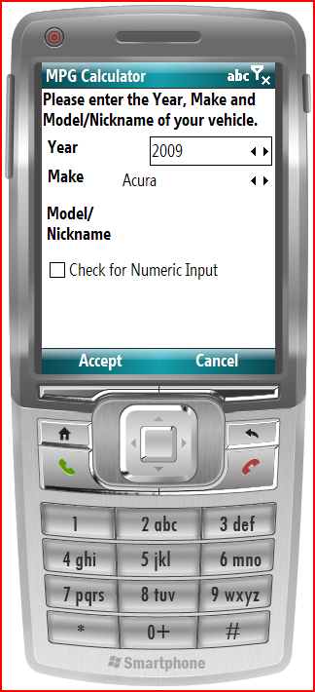

Once desired vehicle information has been entered, choose Accept.

Scrolling through Any List in the Application

For any list in the application (see Example A-1 below), you may use the left and right arrows on the D-pad to scroll back and forth through the list.

Alternately, you may press the middle button on the D-pad to pull up the list in full-screen mode (see Example A-2 below). then use the up and down arrows to scroll through the list. Press the middle button on the D-pad to choose the highlighted item.

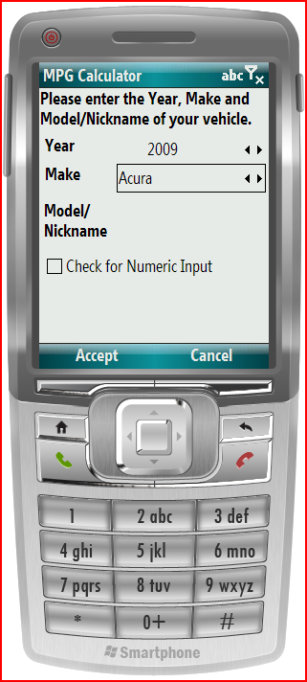  Example A-1 | 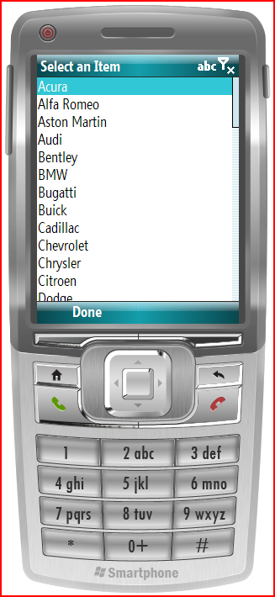  Example A-2

Choosing an Existing Vehicle

If historical data exists, choose a vehicle using the left and right arrows to scroll through the existing list of vehicles.

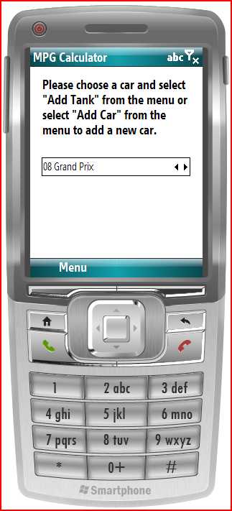

Then choose Menu → Add Tank.

Entering Fuel Data

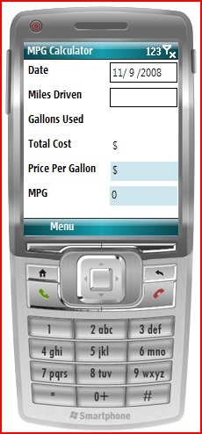

Enter the following fuel data:

Date Enter date in mm/dd/yyyy format.
Default is current date.

Miles Driven Enter miles driven. May enter up to 1 digit after the decimal point.

Gallons Used Enter gallons of fuel used. May enter up to 3 digits after the decimal point.

Total Cost Enter cost of fuel used. May enter up to 2 digits after the decimal point.

Price Per Gallon Display-only, auto-calculated field. Total Cost/Gallons Used.

MPG Display-only, auto-calculated field. Miles Driven/Gallons Used.

Note: As data is entered, calculations are performed automatically, where possible.

Saving Fuel Data

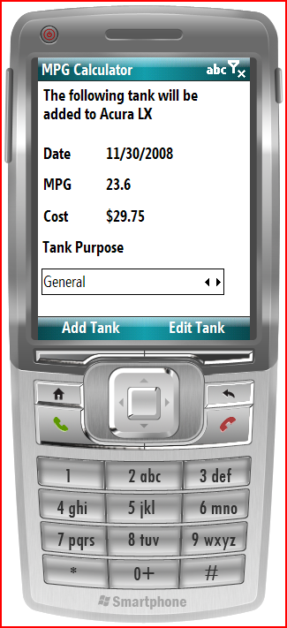

The save fuel data confirmation screen displays. Choose a purpose for the tank of fuel: General, Business, or Travel.

Choose either:
- Add Tank, or
- Edit Tank

Choosing the Add Tank option saves the fuel data to the data file. Choosing the Edit Tank option re-enters the fuel data entry screen (see Entering Fuel Data), which allows changing any of the editable fields.

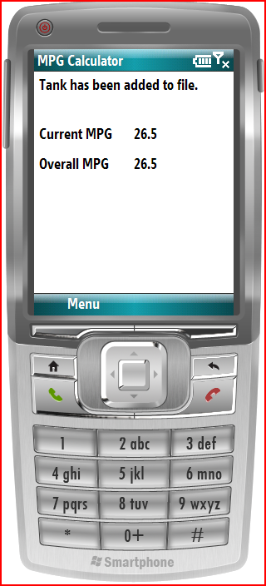

The tank added confirmation screen shows both current and overall historical performance data for this specific vehicle.

Displaying Fuel-Saving Tips

To display fuel-saving tips, from the tank added confirmation screen choose Menu → Tips.

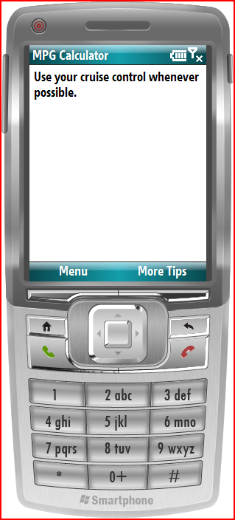

To display additional fuel-saving tips, choose More Tips.

Displaying Historical Performance

Attempting to Summarize or Compare without Stored Data

In order to summarize or compare historical performance, one or more tanks of MPG Calculator™ data must have been previously stored.

If you choose to summarize or compare and no historical performance data exists, the performance error screen displays (see below).

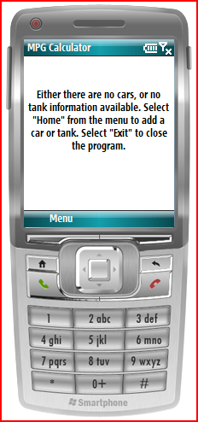

If you receive the performance error screen, you may choose either:
- Menu → Home to return to the MPG Calculator™ home page, then add a tank of fuel, or
- Menu → Exit to close the MPG Calculator™ application and return to the phone’s Home.

Summarizing Performance for One Vehicle over Time

To summarize historical performance over time for a single vehicle, from the MPG Calculator™ main menu choose Historical Data → One Car → Summary.

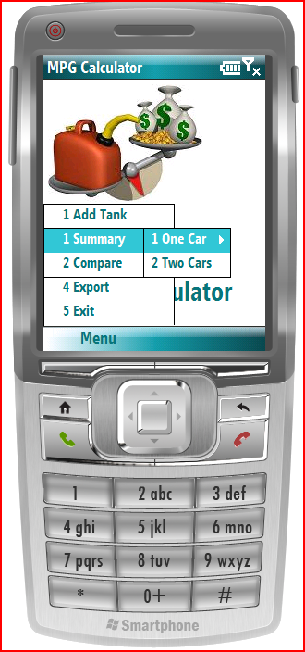

Choose a car by scrolling through the list of cars. Then, choose a From date and a To date for your summary date range.

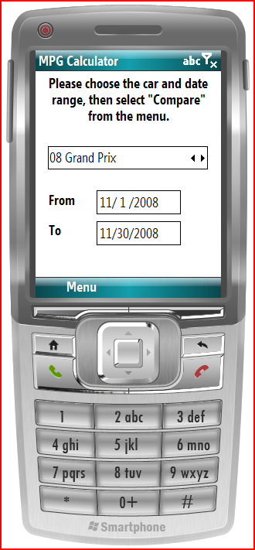

Comparing Performance for One Vehicle over Time

To compare historical performance over time for a single vehicle, from the MPG Calculator™ main menu choose Historical Data → One Car → Compare.

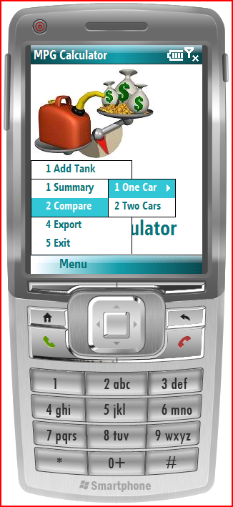

Choose a vehicle by scrolling through the list of vehicles. Then, choose a From date and a To date for the first date range, and a From date and a To date for the second date range.

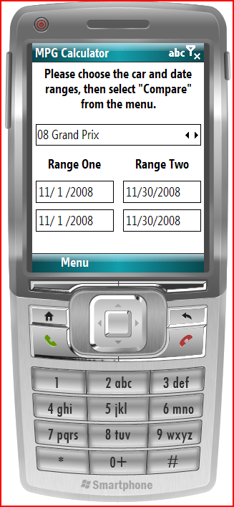

Then choose Menu → Compare.

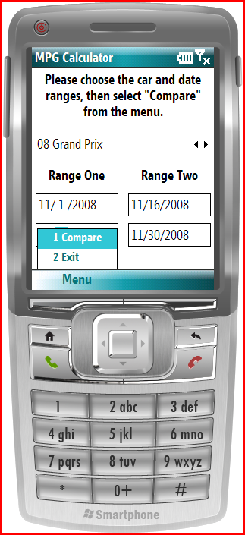

Comparing Performance for Two Vehicles

To compare historical performance over time for a single vehicle, from the MPG Calculator™ main menu choose Historical Data → Two Cars.

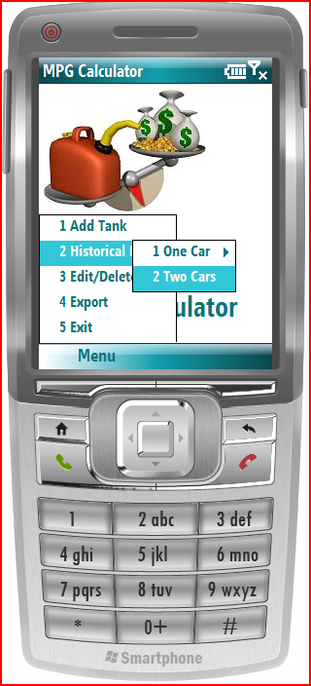

Attempting to Compare Two Vehicles When Only One Exists

If you attempt to compare two vehicles when only one vehicle exists, an error screen displays. You must add another vehicle and at least one tank of fuel for that vehicle.

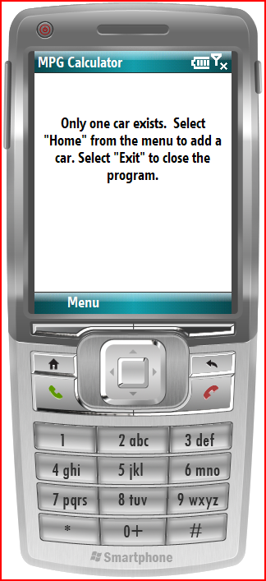

Choose a vehicle, a From date, and a To date for each range.

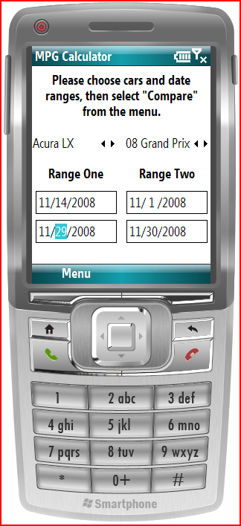

Then choose Menu → Compare to initiate the historical performance comparison calculations.

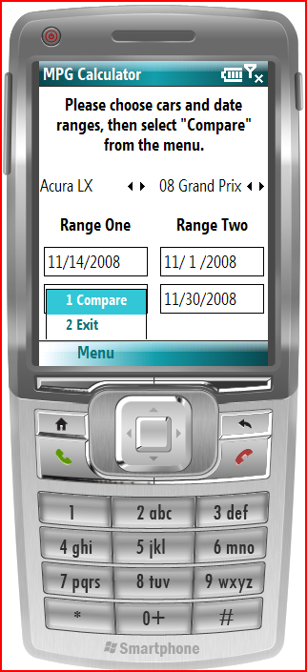

Displaying Performance Comparison

After choosing to compare historical performance, the Performance Comparison screen (see below) displays the following information for each date range:
- Total Cost
- Price
- Miles Driven
- Gallons Used
- MPG

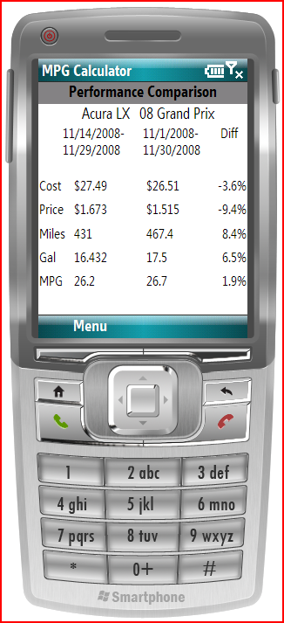

Additionally, the last column of the Performance Comparison screen displays the change percentage between the date ranges for each data value.

Editing/Deleting Data

To edit or delete historical performance data for a vehicle, from the main MPG Calculator™ menu, choose Edit/Delete.

Then choose a vehicle for which data will be edited or deleted by scrolling through the alphabetical listing of vehicles. Choose an option:

Delete Car
Delete a vehicle including all its historical performance data

Edit/Delete Tank
Edit or delete a single tank of fuel for a vehicle

Cancel
Return to the MPG Calculator™ main menu

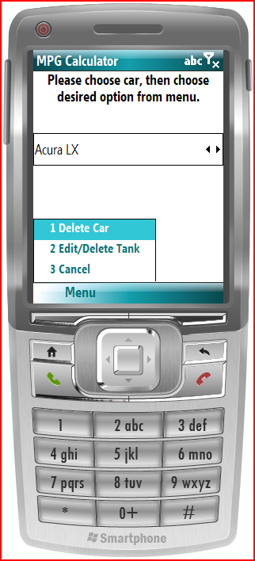

Deleting a Vehicle

To delete a vehicle, from the Edit/Delete menu, choose Delete Car.

From the vehicle deletion screen, choose one of the following:

Yes
Delete the chosen vehicle

No
Do not delete the vehicle; return to the main MPG Calculator™ screen

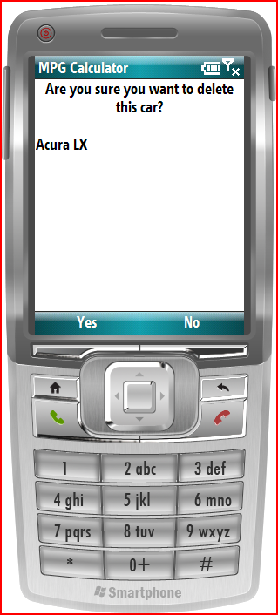

Editing or Deleting a Tank of Fuel

To edit or delete a vehicle’s tank of fuel, from the Edit/Delete menu, choose Edit/Delete Tank.

On the vehicle deletion screen, choose a tank of fuel to edit or delete by scrolling through the list of tanks for the previously chosen vehicle using the left and right arrows.

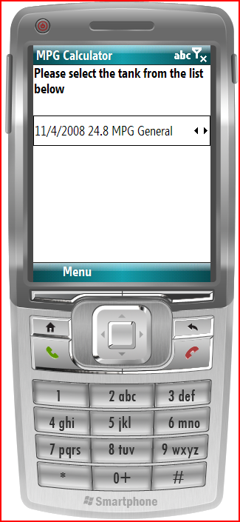

From the tank edit/deletion screen menu, choose:

Edit Tank
Edit the chosen tank of fuel; see previous section Adding a Tank of Fuel

Delete Tank
Delete the chosen tank of fuel

Cancel
Returns to the main MPG Calculator™ screen

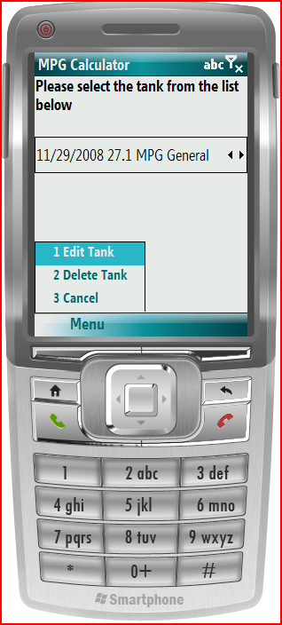

Exporting Historical Performance Data

To export historical performance data for a vehicle to a comma-delimited file, from the main MPG Calculator™ menu, choose Export.

Then choose a vehicle by scrolling through the alphabetical list of available vehicles. Choose the Export option.

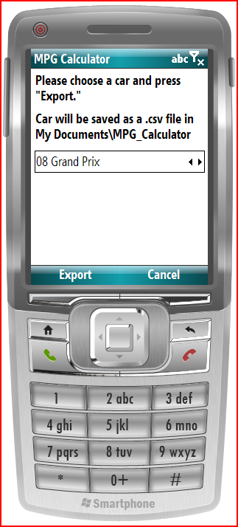

The file of historical performance data is then exported.

To locate the stored comma-delimited file of historical performance data, search the My Documents\MPG_Calculator folder on your phone.

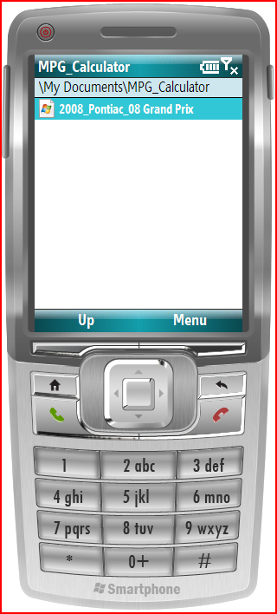

Glossary

MPG
Miles per gallon; objectively measures a vehicle’s performance efficiency by reflecting the number of miles driven for each gallon of gasoline consumed by the vehicle.

PDA
Personal digital assistant; a miniature handheld computer, usually with limited functionality, memory, and storage.

RAM
Random access memory; main computer storage available for programs and data.

Smartphone
A cellular phone that incorporates features inherent in a PDA.

VIN
Vehicle identification number; a series of letters and numbers that uniquely identifies a motor vehicle.

